Tutorial link:

<https://www.youtube.com/watch?v=k-zMkzmduqI>

# Camera Movement

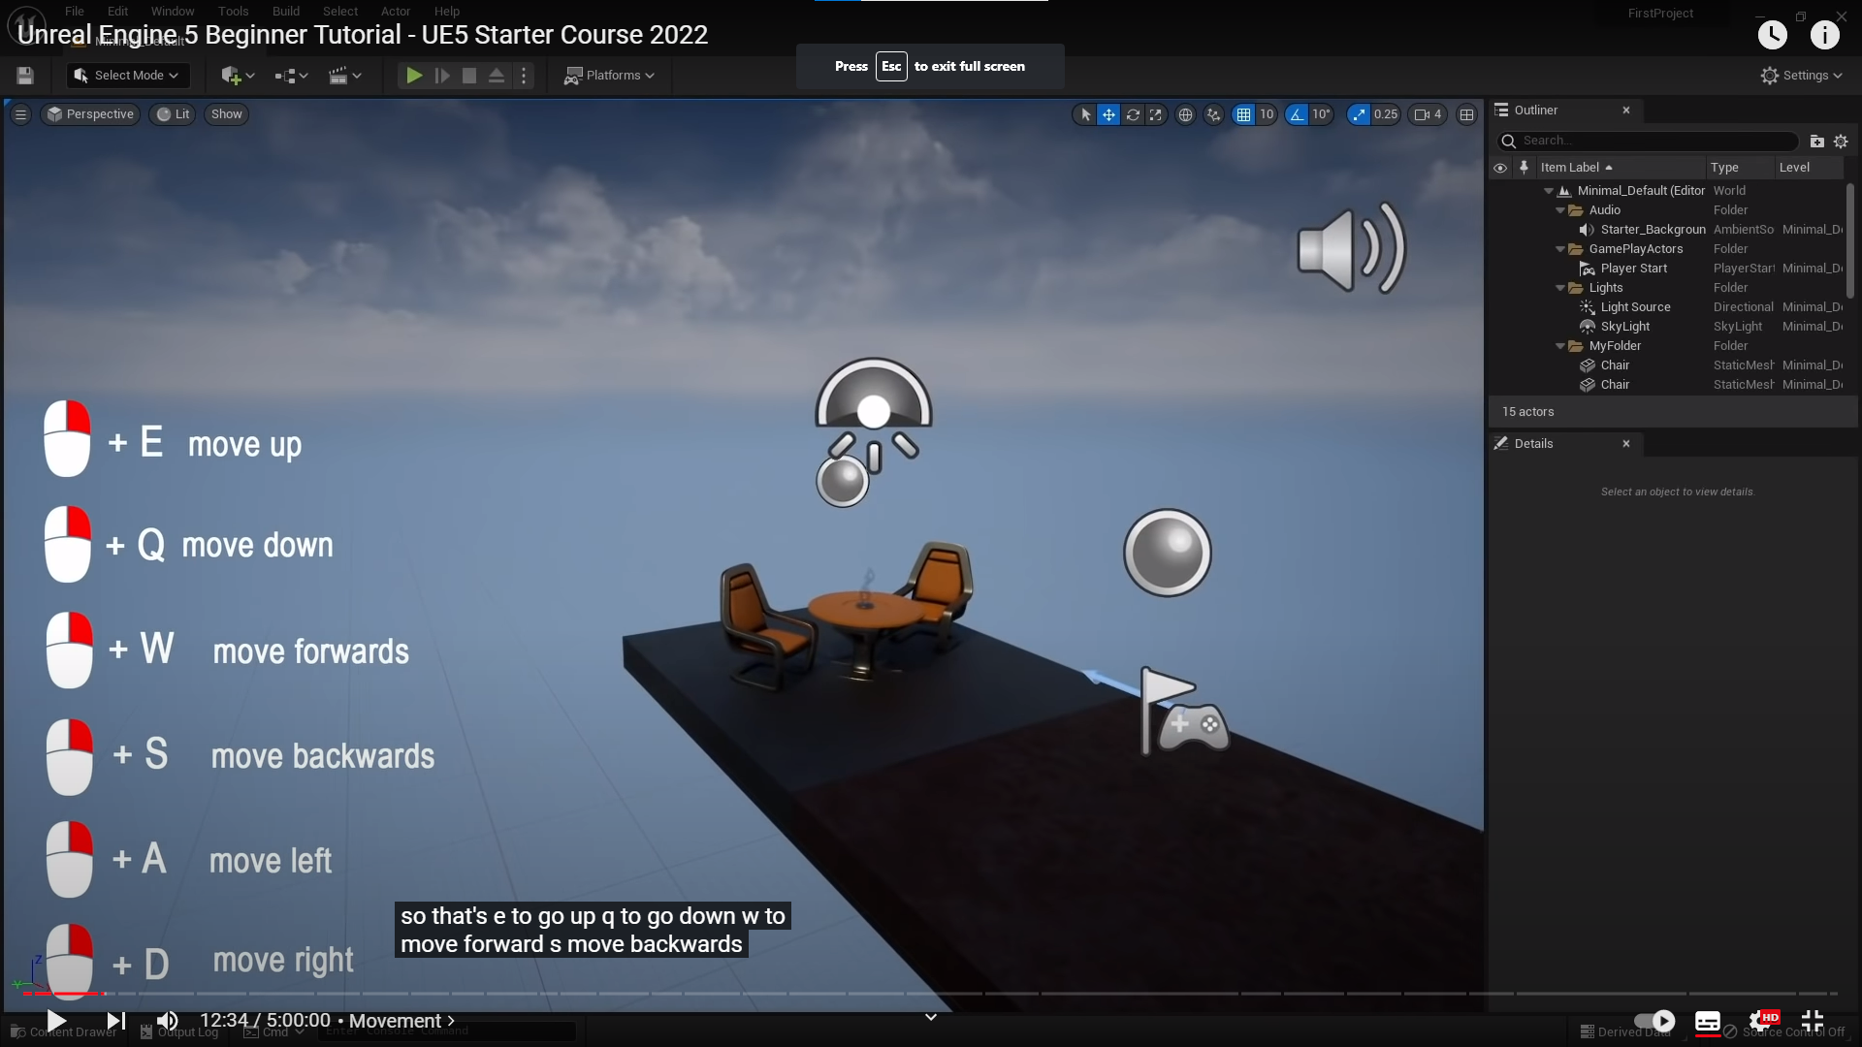

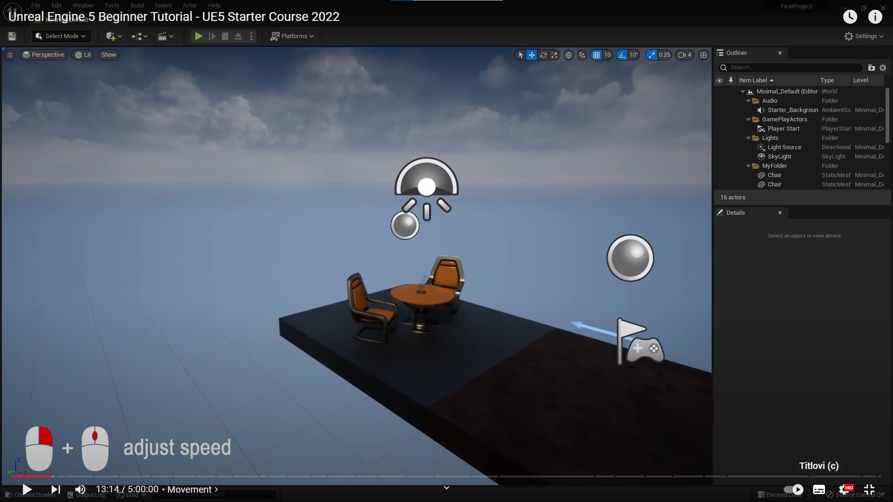

Rotate around object:

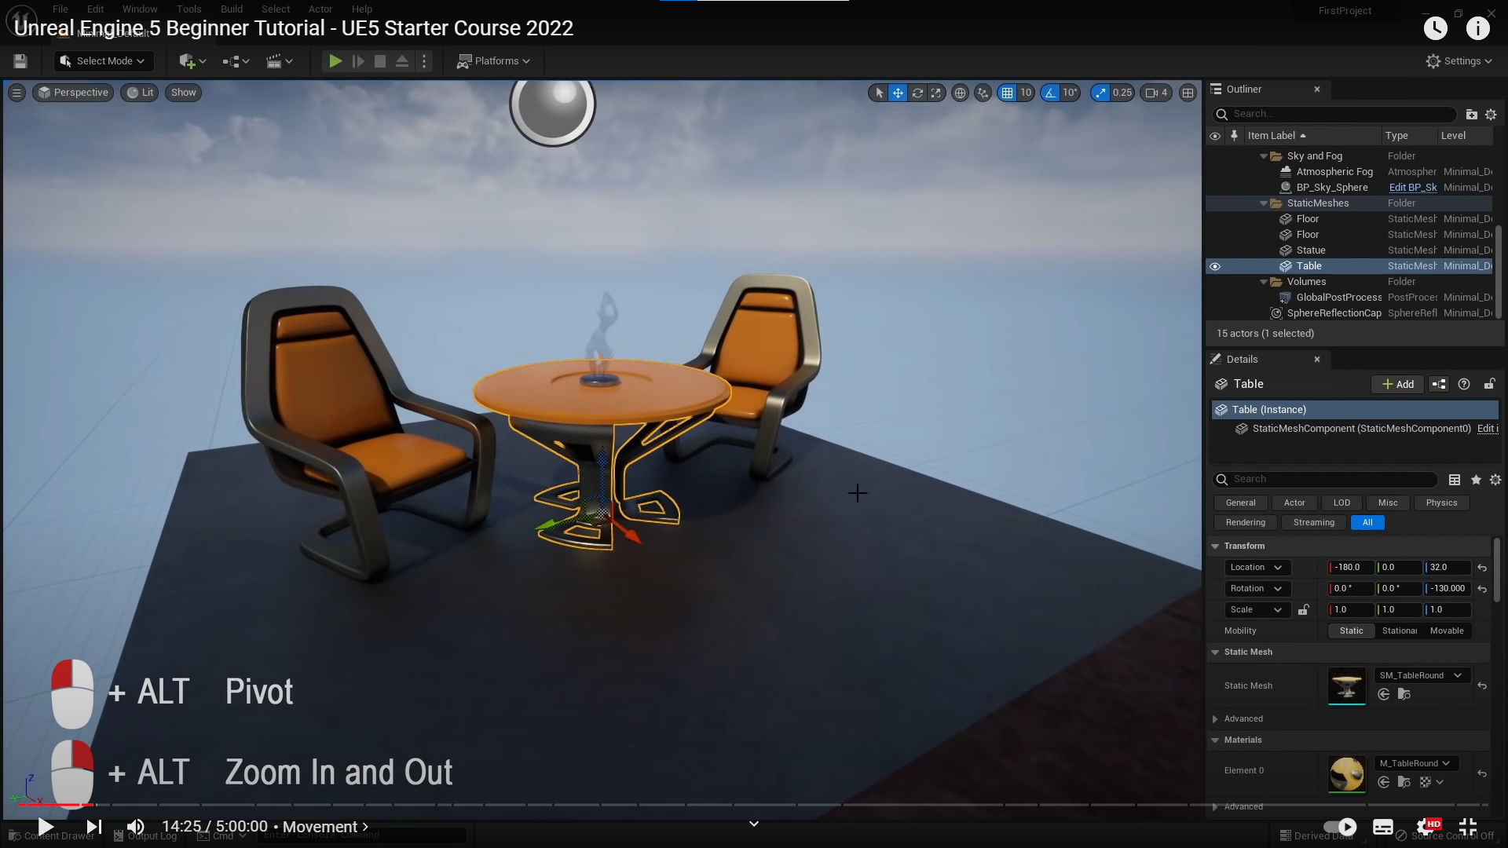

Connect object to bottom object(floor)

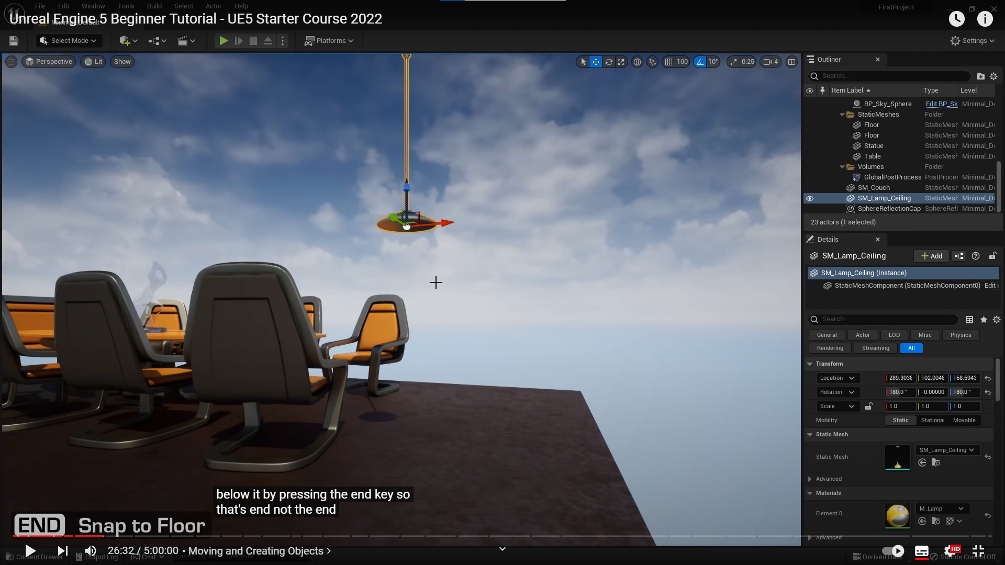

# Image rendering

UE has its image rendering properties located in Hierarchy -> Volumes -> GlobalPostProcessingVolume

This is only regarding to processing via camera, not for lighting settings(if understood correctly)

Here we can adjust settings:

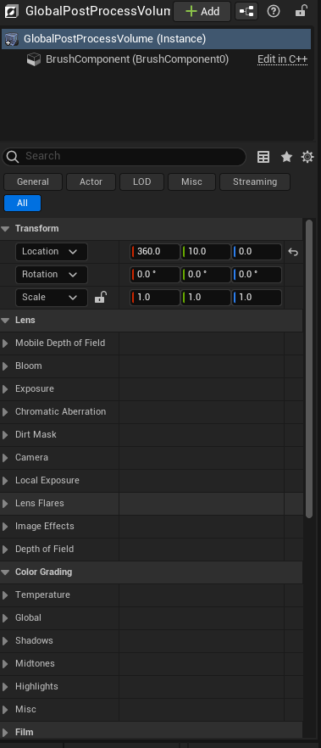

# Materials

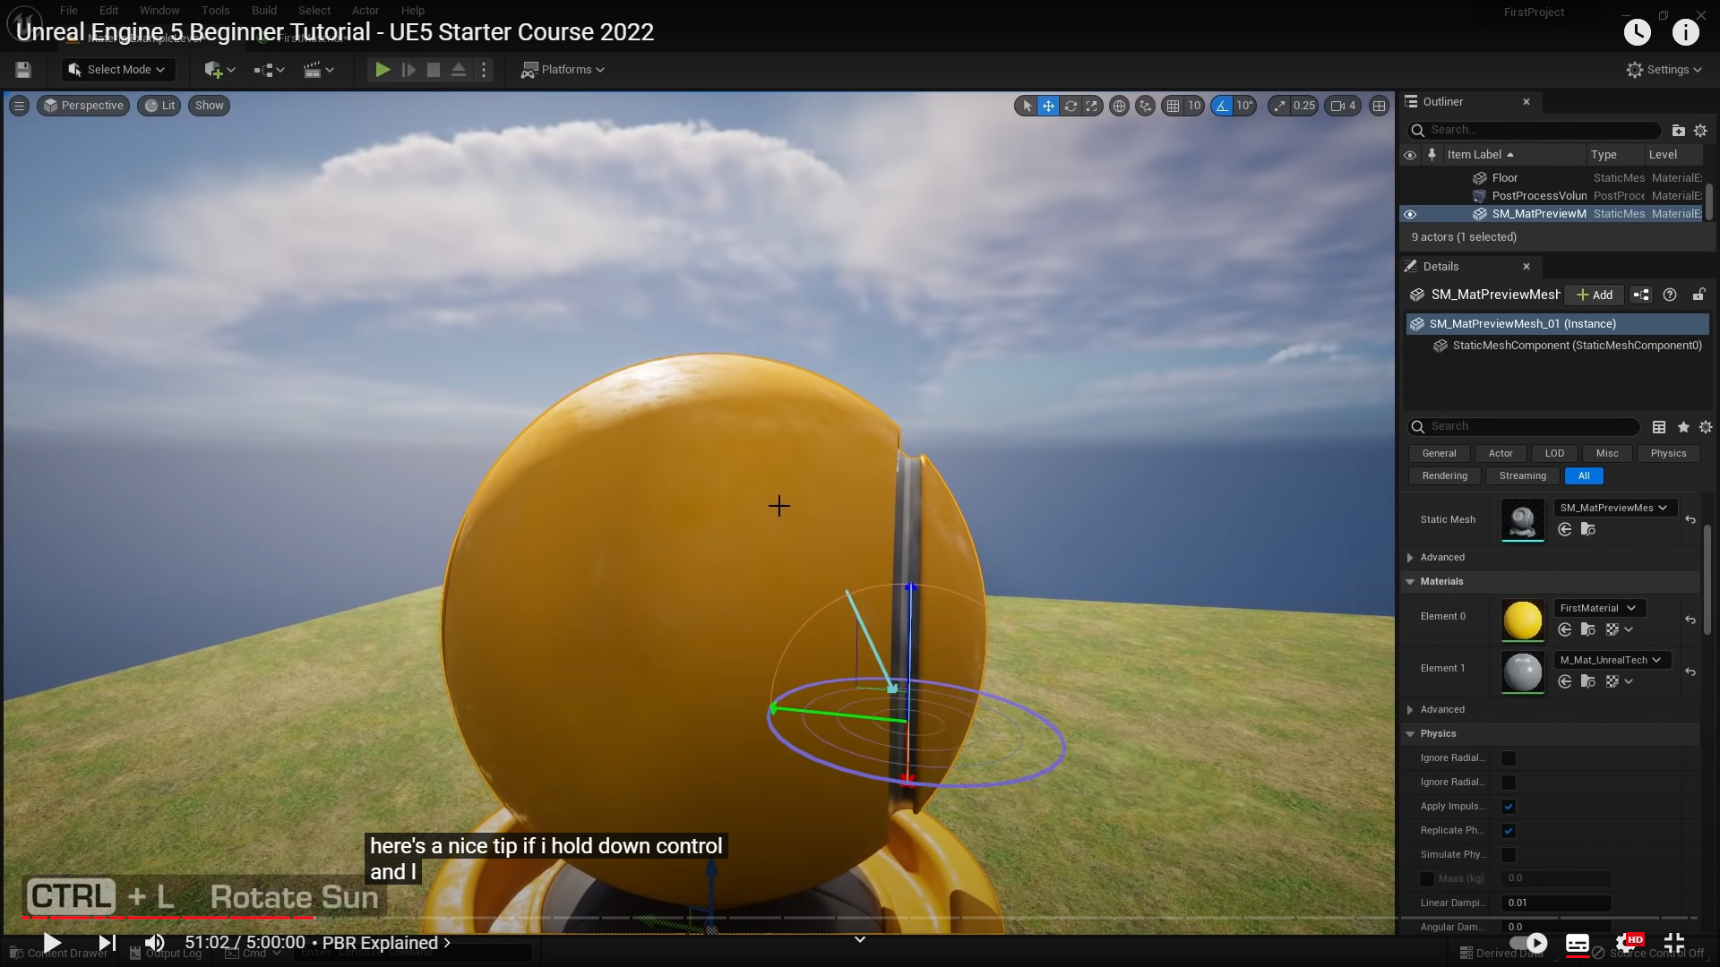

Alt+4 -> normalni mode, vidi se ka I gori

Alt+3 -> color mode, vide se samo boje prema slici doli:

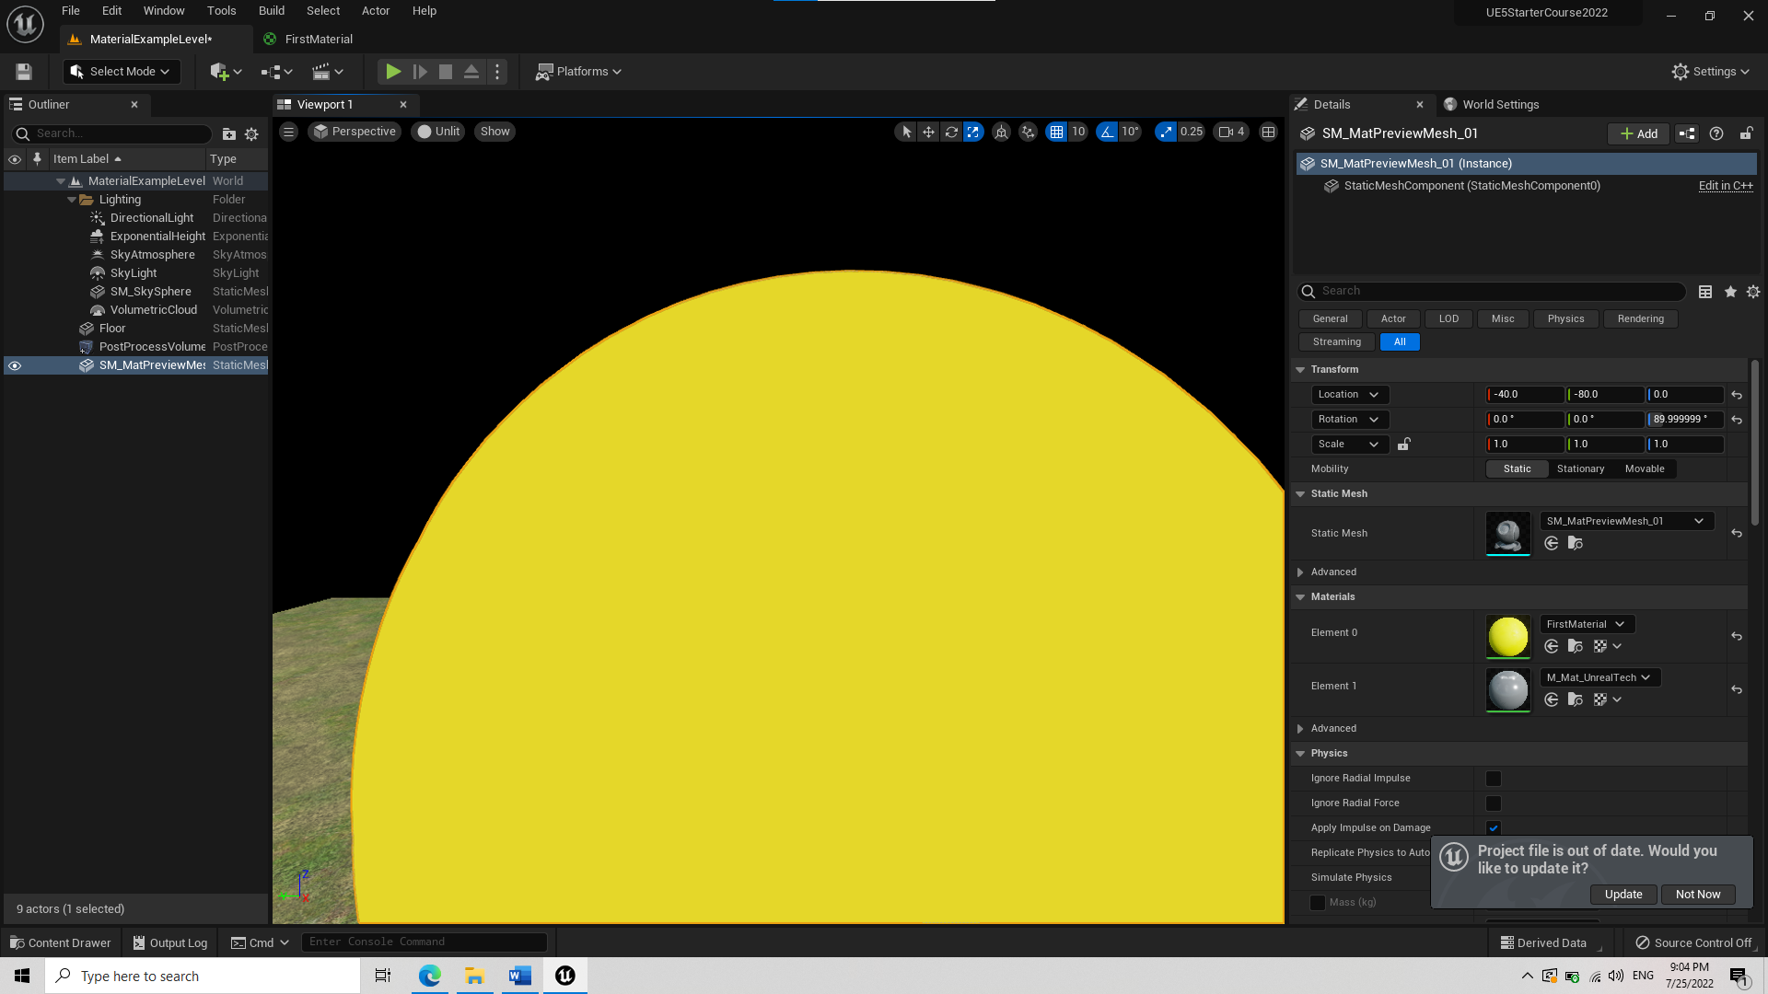

If you open a texture and don’t see it press A for alpha:

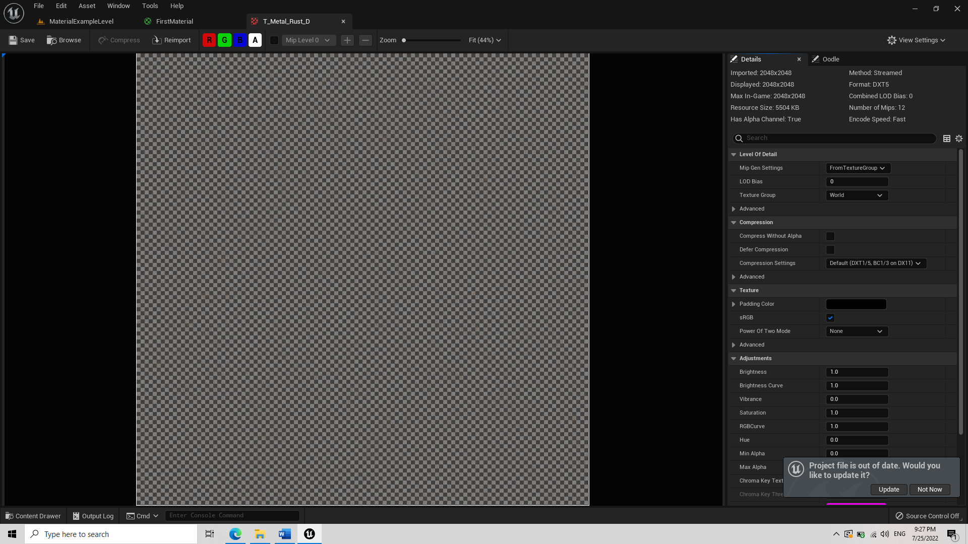

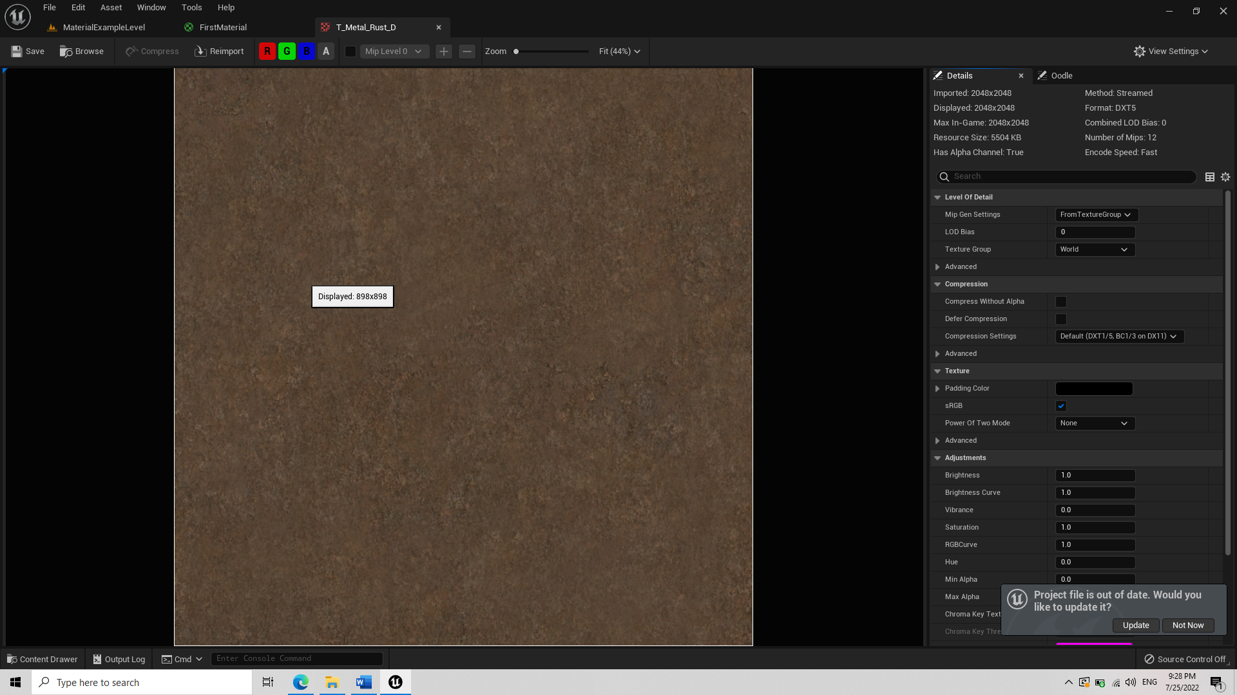

Details about which texture should contain what properties: tutorial link at start, min 55:00 start, end cca 58:00 mins

# Import models

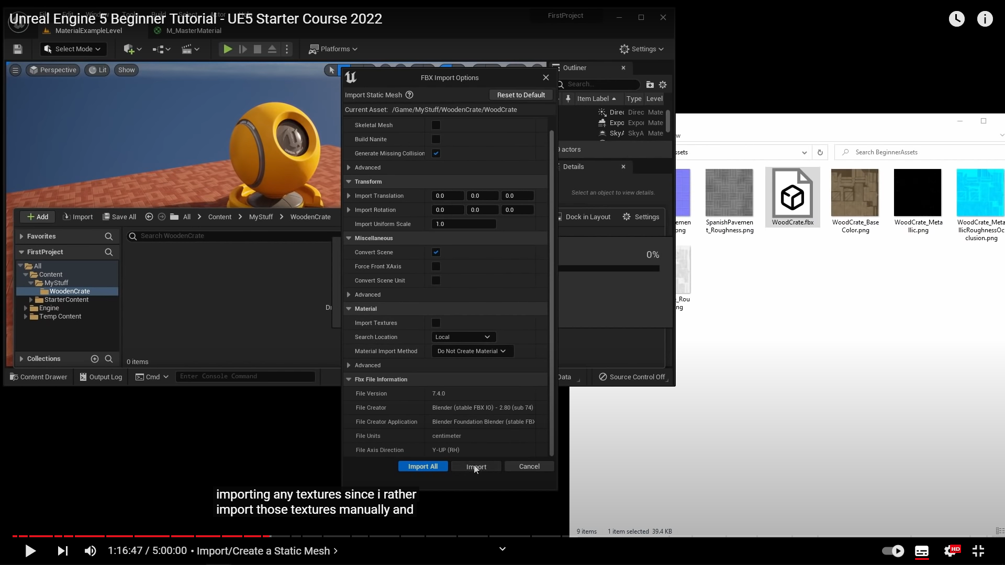

1:19:00 -> details about textures, rgba data, fun fact

# Lighting – Lumen

1:27:00 starting timer

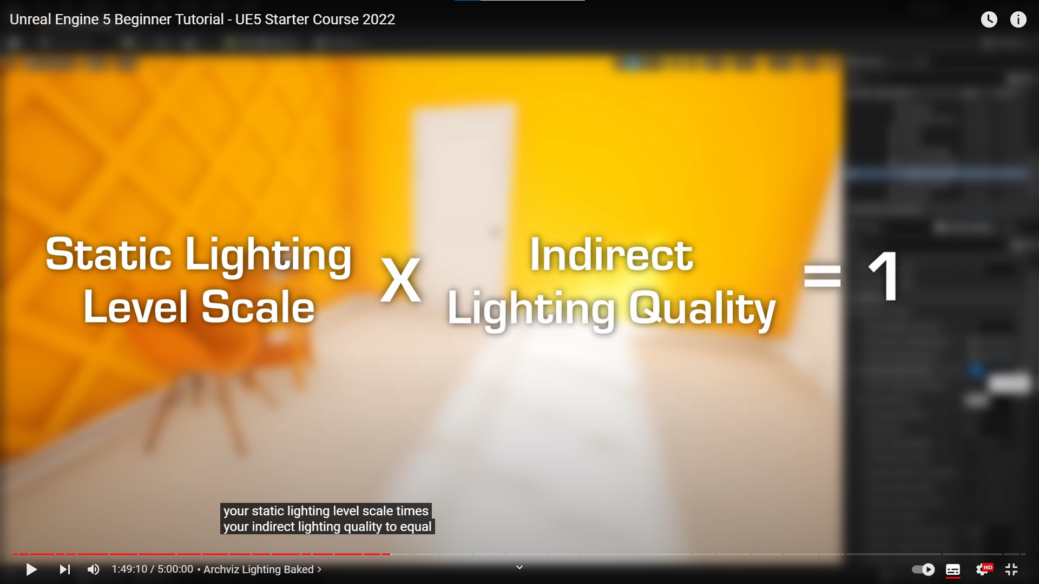

When baking lighting you should consider equation above.

For details regarding resolution of objects:

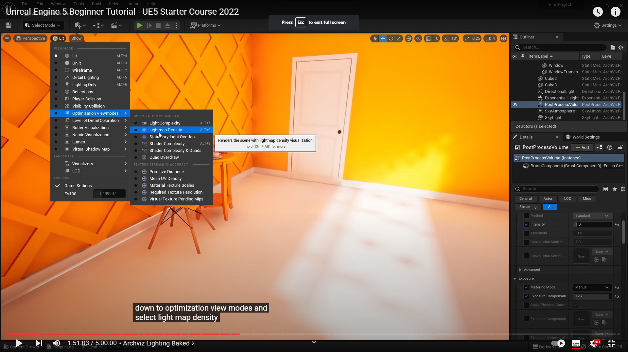

# Landscape

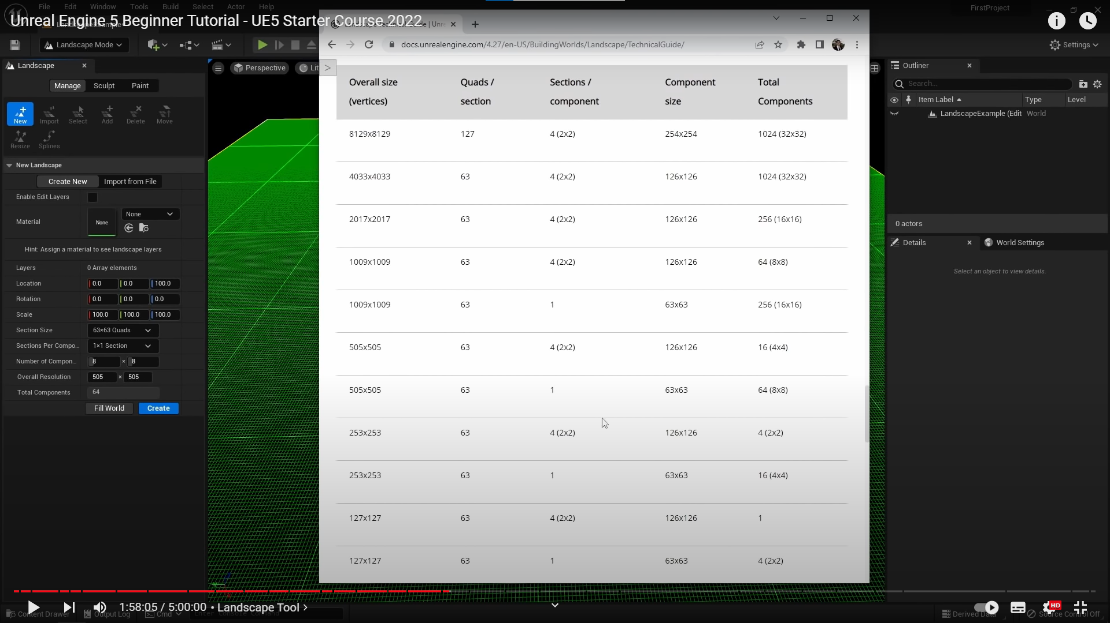

Changing landscape settings

2:04:00 – 2:13:00 landscape material

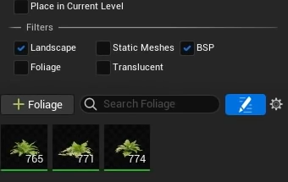

Disable static meshes if you don’t want to paint foliage over objects

Enable nanite:

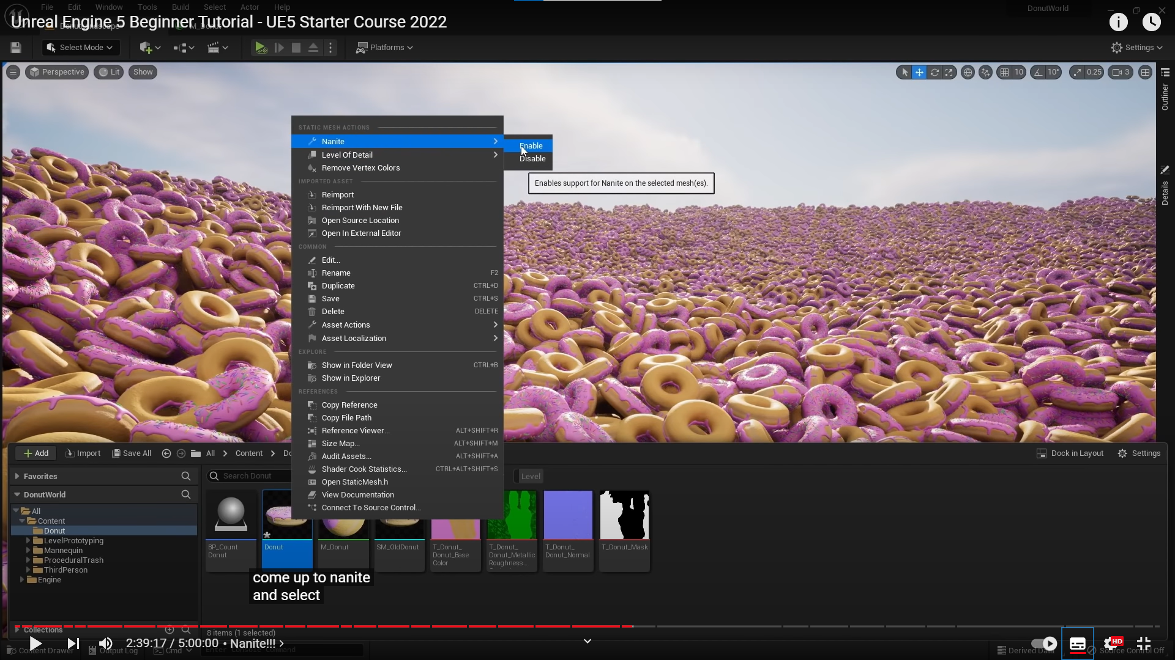

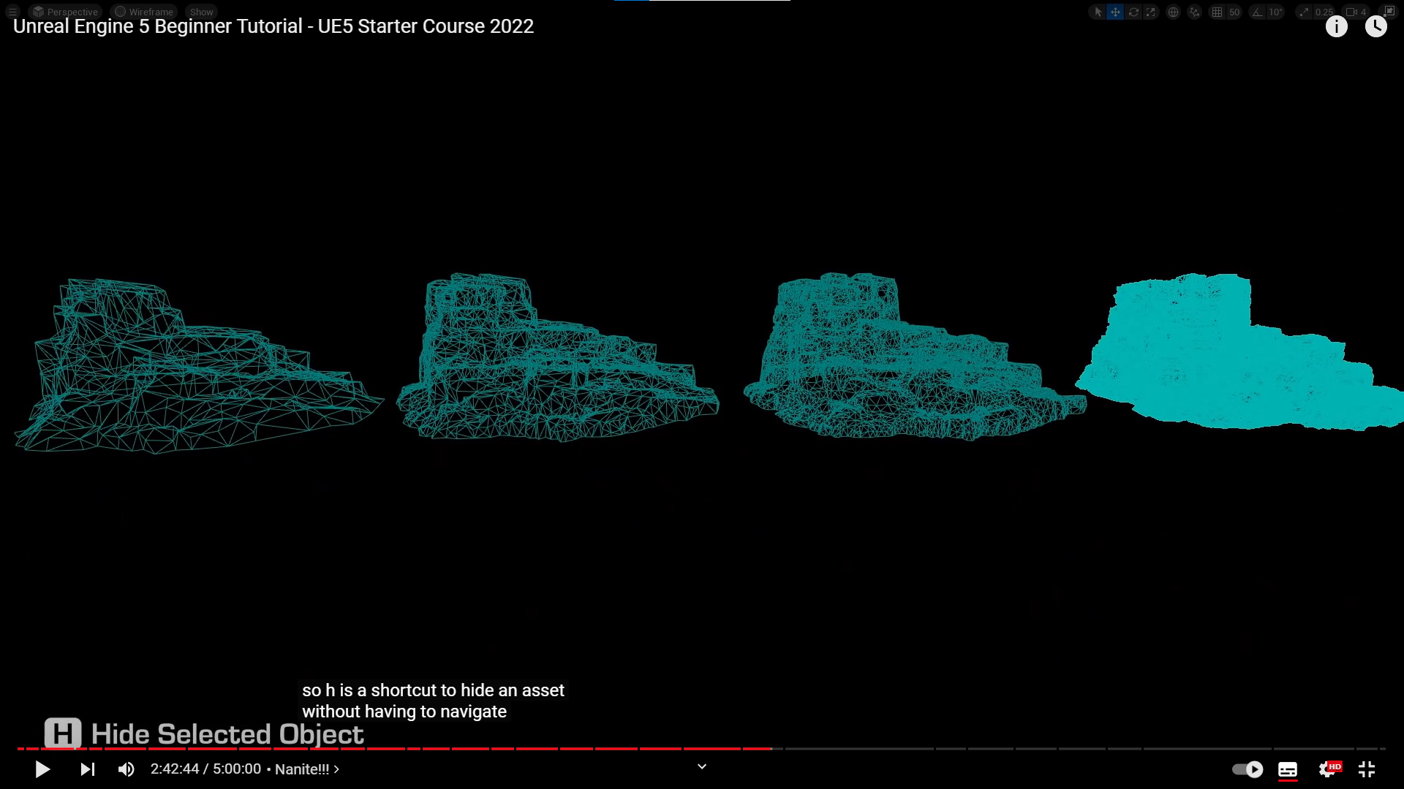

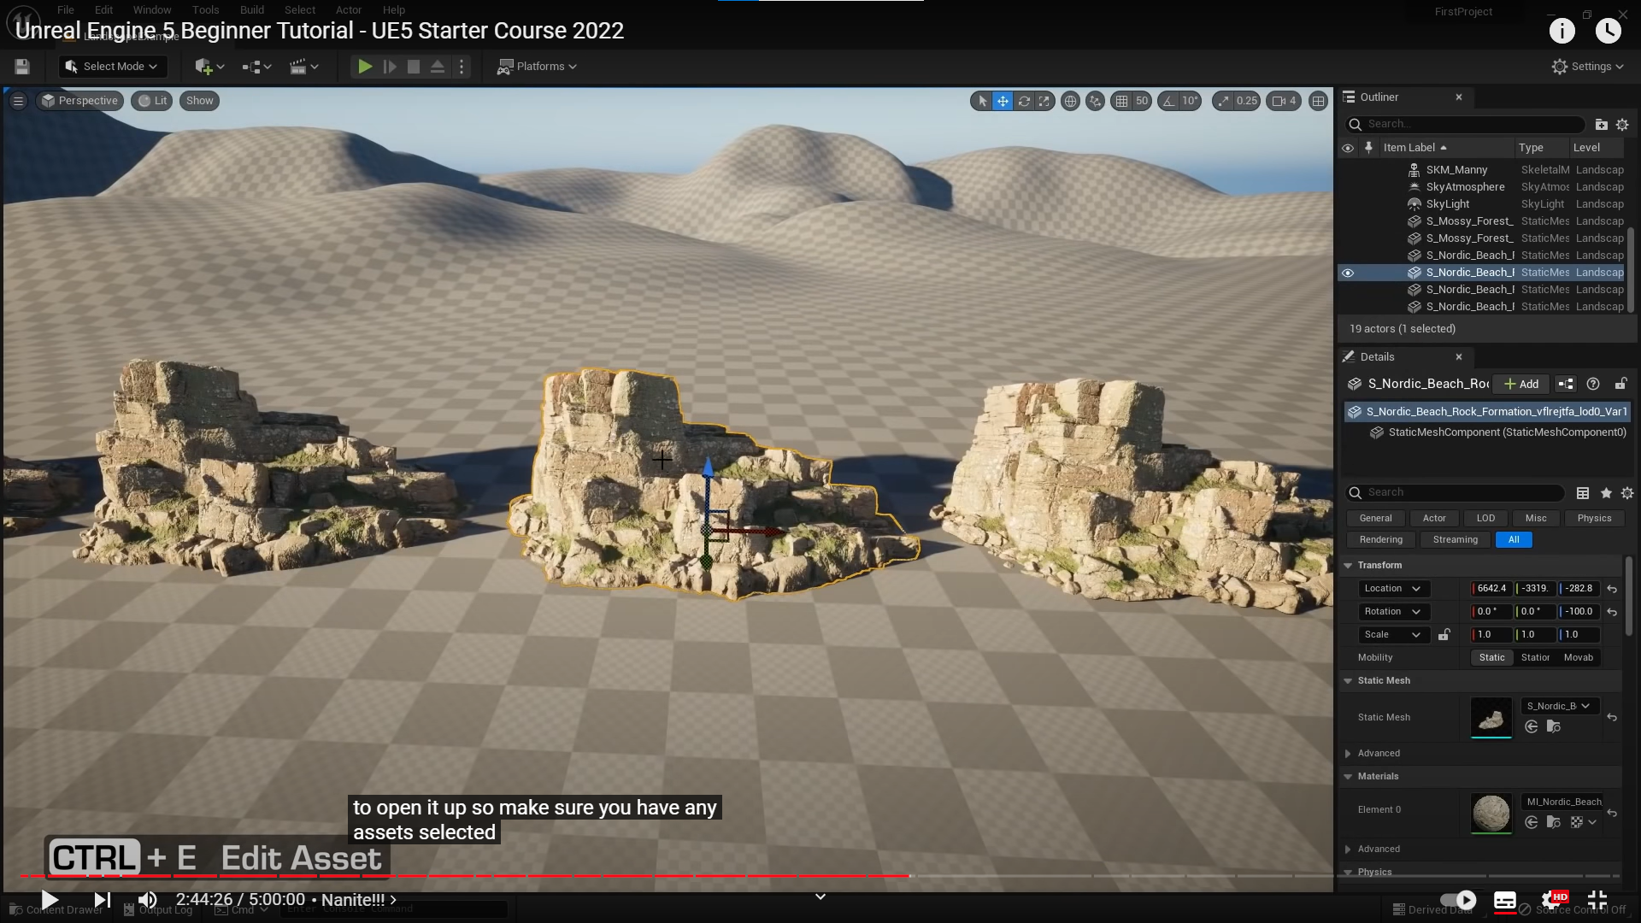

# Blueprints

Game modes are set in world settings window -> Game mode

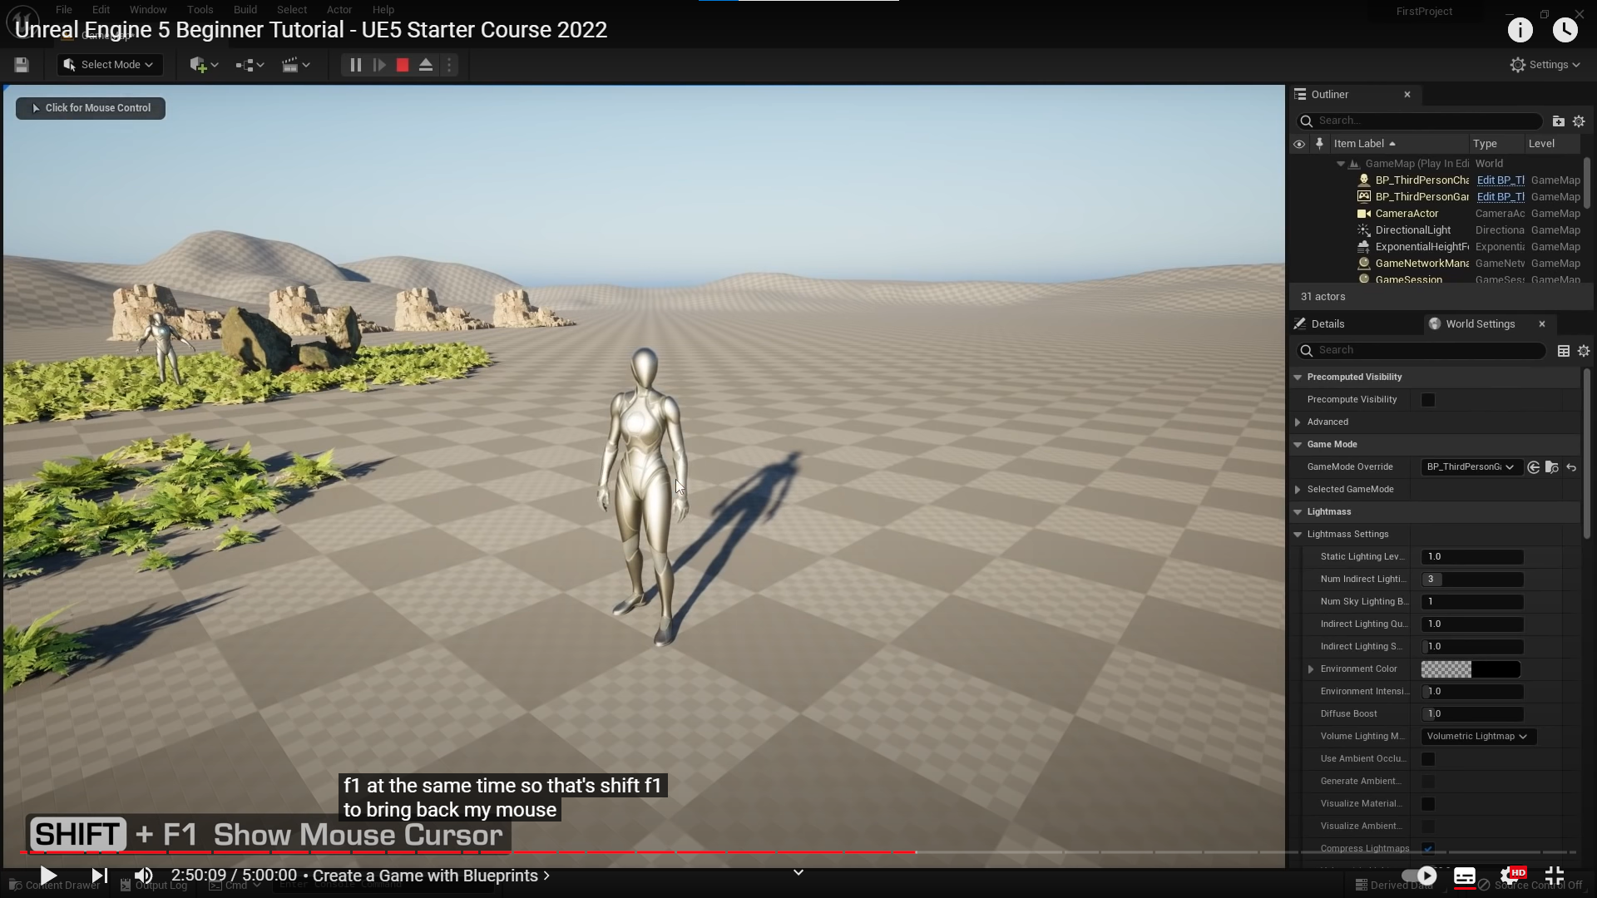

Debuging blueprints:

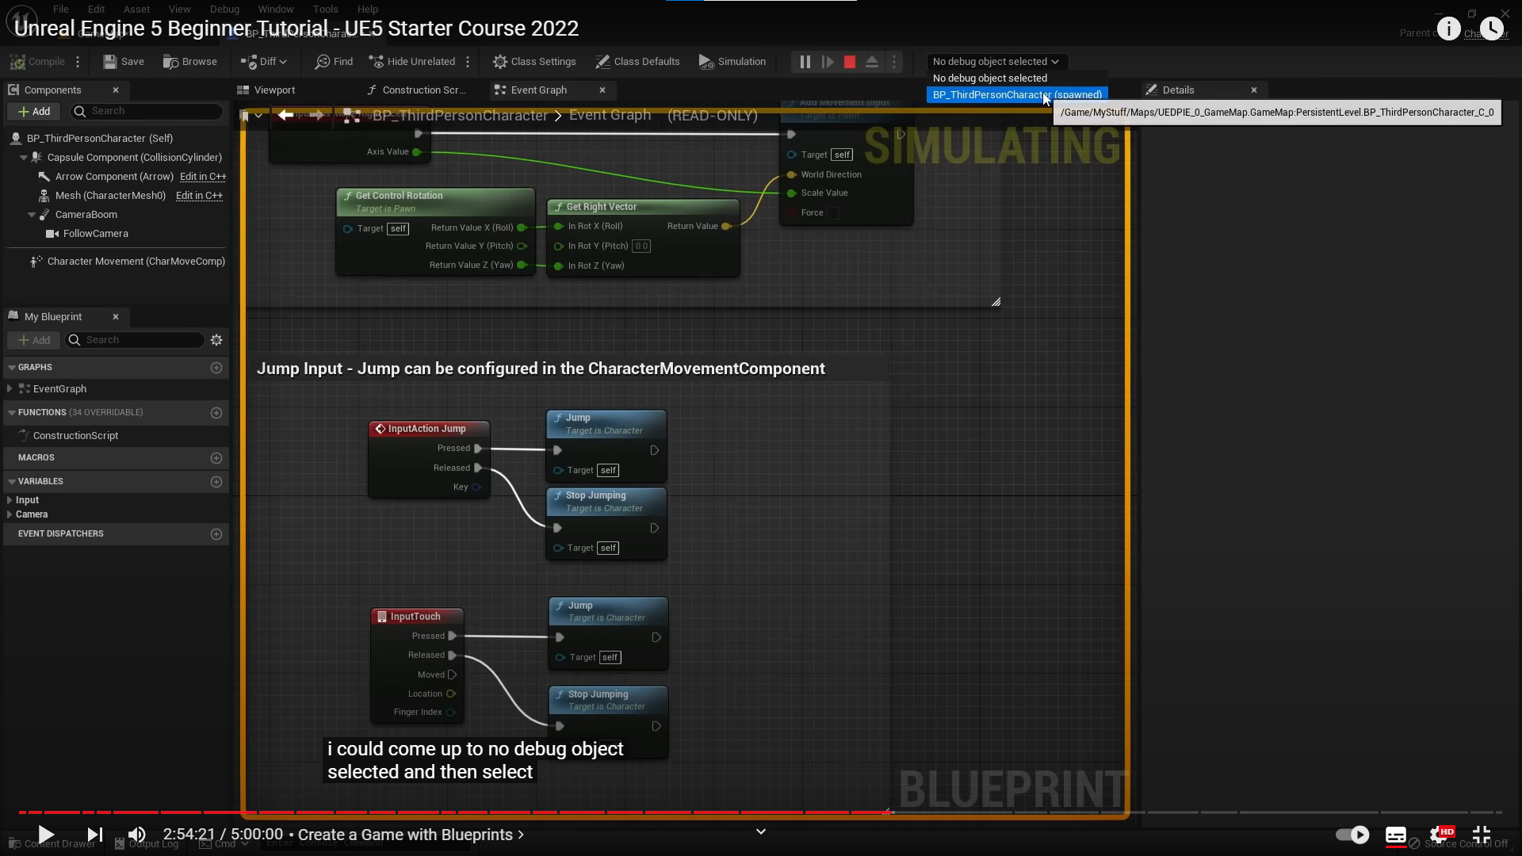

3:05:00 -> continue here with collision blueprint